# COMP3500: Midterm Exam 1 – Exercises

**Exercise 1:** Two processes cooperate in computing the sum of the first N odd integers. Add appropriate semaphore declarations and signal and wait statements to these programs so that the proper value of Sqr (i.e., 25) will be printed out.

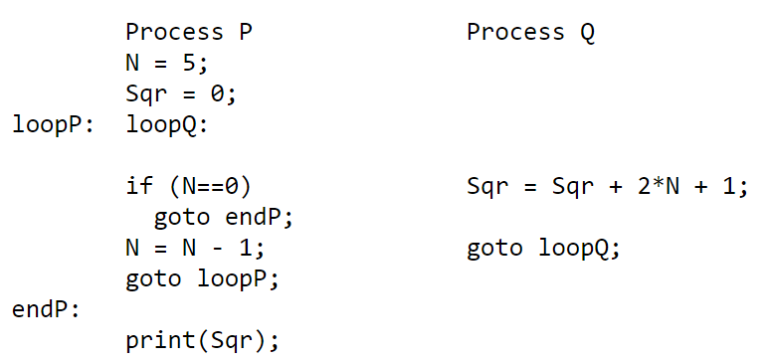

**Exercise 2:** The Cigarette Smoker's Problem. There are three smokers and one cigarette dealer. A smoker must make a cigarette before he or she can smoke it. Making a cigarette requires (1) tobacco, (2) paper, and (3) matches. Each smoker has one of the three items. Specifically, one smoker has tobacco, another has paper, and a third one has matches. The cigarette dealer has an infinite supply of tobacco, paper, and matches. The dealer randomly selects two of the three items and places them on a table. Then, the smoker who has the third item makes a cigarette and smoke. After the first smoker finishes smoking, the dealer will place other two of the three items on the table so that another smoker can enjoy cigarettes. Please use semaphores to synchronize the three smokers and the dealer.